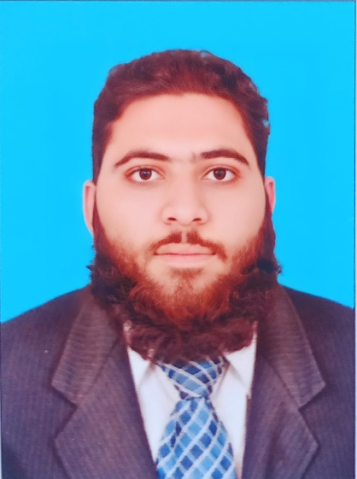



PERSONAL
- TIME MANAGMENT
- ACTIVE LISTNER
- MOTIVATION
- NEGOTIATION
- EFFECTIVE GROUP & INDIVIDUAL WORKABILITY
EXPERIENCE
ISLAMIAT TEACHER AND VICE PRINCIPLE TWO YEAR
AT THE LEARNING VILLAGE SCHOOL SWAT
EDUCATION
SHAHADAT UL ALAMIA YEAR OF COMPLITION -(2022)
FROM DAR UL ULOOM KARACHI

B.A. Applied Economics YEAR OF COMPLITION-(2020)
FROM UNIVERSITY OF KARACHI
F.A (FACULTY OF ARTS) YEAR OF COMPLITION-(2017)
FROM BOARD OF INTERMIDITE KARACHI
MATRICULATION (IN SCIENCE) YEAR OF COMPLITION-(2014)
FROM BOARD OF SECONDARY EDUCATION KARACHI

ENGLISH

URDU

ARABIC

PERSNOL DETAILS
F/NAME: MUHAMMAD SHERIN
DOB: 05 MARCH 1998
CNIC NO: 42401-9530481-3
RELIGION: ISLAM
- HAFIZ UL QURAN

- BASIC KNOWLADGE OF COMPUTER AND MS OFFICE

- ISLAMIC BANKING

- INTERNET SUFFERING

LANGUAGES
CONTACT
SKILLS
STREET NO #32, SECTOR C, TOWNSHIP KANJU SWAT.
SH2087706@gmail.com
+92 3432087706
OBJECTIVE
To work in a distinguished and dynamic organization where one can exploit his potential to the maximum and to prop up his theoretical knowledge with solid practical experience. The organization should have an environment that can inculcate the spirit and culture of teamwork at the outset of one’s career.
SADDAM HUSSAIN

